Image Analytics

TOPIC: Image Segmentation

Joel John Joseph

- Introduction

Image segmentation is a fundamental task in computer vision that involves partitioning an image into multiple segments or regions based on certain criteria, such as color, intensity, texture, or other visual properties. The primary goal of image segmentation is to simplify the representation of an image or make it more meaningful and easier to analyze. Unlike image classification, which assigns a single label to an entire image, segmentation provides a more detailed understanding by delineating individual objects or regions within the image.

The process of Image segmentation facilitates a more granular understanding of the image content, surpassing the limitations of traditional image classification. Semantic segmentation involves classifying each pixel into semantically meaningful categories, such as objects or regions, while instance segmentation goes a step further by distinguishing individual instances of objects. Deep learning techniques, particularly Convolutional Neural Networks (CNNs), have significantly advanced image segmentation, offering improved accuracy and efficiency.

Applications span various domains, including medical imaging, autonomous vehicles, satellite imagery analysis, and object recognition. The precision of image segmentation is vital for extracting meaningful insights from visual data, contributing to advancements in computer vision and intelligent system development.

Efficient and accurate image segmentation is essential for many computer vision tasks, as it forms the basis for subsequent analysis, interpretation, and decision-making in various fields. Advances in image segmentation continue to drive progress in computer vision applications and contribute to the development of intelligent systems.

- Methodology

The following Segmentation techniques have be understood for implementation purpose of the project:

2.1 Region-Based Segmentation:
Region-based segmentation groups pixels with similar properties into coherent regions. Common techniques involve partitioning an image based on intensity, color, or texture homogeneity. The resulting regions represent distinct objects or segments within the image, making it a valuable approach for tasks where pixel homogeneity is a key criterion.

2.2 Edge-Based Segmentation:
Edge-based segmentation focuses on detecting abrupt changes in intensity within an image. Edges typically represent object boundaries, and this method involves identifying points where intensity changes sharply. Techniques include gradient analysis to highlight regions with significant intensity variations, providing a clear delineation of object boundaries.

2.3 Contour-Based Segmentation:
Contour-based segmentation relies on continuous curves or contours to outline object boundaries. By emphasizing the smooth representation of object edges, this method offers a more refined approach compared to edge-based techniques. Contour information can be crucial for applications requiring precise shape and boundary information.

2.4 K-Means Clustering Segmentation:
K-Means clustering is a popular unsupervised machine learning algorithm used for segmentation. In image processing, K-Means groups pixels into clusters based on similarity in color or intensity. This approach is effective for partitioning images into distinct regions, with each cluster representing a specific segment.

2.5 U-Net Segmentation:
U-Net is a convolutional neural network (CNN) architecture designed for semantic segmentation. Its U-shaped structure enables the network to capture fine details and spatial information, making it particularly effective for tasks such as biomedical image segmentation where precise object delineation is crucial.

2.6 SegNet Segmentation:
SegNet is another deep learning architecture specialized for semantic segmentation. It employs an encoder-decoder structure with skip connections to reconstruct high-resolution segmentations. SegNet is known for its efficiency in real-time applications, making it suitable for tasks like road scene understanding in autonomous vehicles.

2.7 Deep-Net Segmentation:
"Deep-Net segmentation" is a broad term referring to the use of deep neural networks for image segmentation tasks. These networks, often based on architectures like CNNs, have demonstrated superior performance in various segmentation applications, ranging from medical imaging to general object recognition, due to their ability to learn intricate features and representations.

2.8 Canny Edge Segmentation:
Canny edge segmentation is an edge detection technique that involves multiple steps, including gradient computation, non-maximum suppression, and edge tracking by hysteresis. It excels at identifying edges in images, providing a foundation for subsequent segmentation or object recognition tasks.

2.9 Otsu Segmentation:
Otsu's method is a histogram-based segmentation technique used for automatic thresholding. It calculates an optimal intensity threshold to separate pixels into two classes, effectively segmenting the image into foreground and background. Otsu segmentation is particularly useful when the distribution of pixel intensities is bimodal.

- Proposed System

The Multi-Model Enhanced Segmenter Segmentation Tool represents an advanced approach to image segmentation, combining the capabilities of four distinct segmentation models: the Facebook Segment Anything Model, UNet, SegNet, and a custom DeepNet. This comprehensive integration enhances the tool's versatility, enabling users to choose the most suitable model for their specific image segmentation requirements.

The usage of the tool begins with a user-friendly interface, allowing for the selection of the desired segmentation model from the available options, including the Facebook Segment Anything Model, UNet, SegNet, and a customizable DeepNet. Users have the flexibility to dynamically manage classes, adding, deleting, or modifying them to tailor the segmentation process to their needs.

The image segmentation process is initiated with a single click, leveraging the selected model. Real-time loading indicators provide feedback during both image loading and segmentation, enhancing the user experience by reducing uncertainty. The segmentation process is streamlined across all integrated models, ensuring a consistent and efficient workflow. Users can interactively add + points with a right-click, add - points with a left-click, and delete the nearest point with a middle-click, providing a responsive and intuitive point editing experience.

The result visualization feature has been unified across all models. Users can click on a class name in the list to instantly view the segmented results for the selected model, facilitating quick and comprehensive feedback. Result outputs are organized in the "masks" folder, segregated by the selected model, making it easy for users to access and manage their segmented outputs.

In addition to the integration of pre-trained models, the tool offers the flexibility for users to train and integrate custom models, empowering them to address specific segmentation challenges unique to their datasets. This capability allows users to tailor the tool to their specific needs, ensuring a more personalized and effective segmentation solution.
Usage Guidelines

Open Image:
Launch the tool and open an image. The loading indicator provides real-time feedback during this process.

Model Selection:
Choose the desired segmentation model (Facebook Segment Anything, UNet, SegNet, or custom DeepNet).

Class Management:
Add, delete, or modify classes as needed before starting the segmentation.

Segmentation Process:
Click "Start" to initiate the segmentation process using the selected model. Editing points is consistent across all models.

Result Visualization:
After segmentation completion, close the figure. Click on the class name in the list to view the segmented results for the selected model.

Custom Model Training (Optional):
For users with specific requirements, train and integrate custom models based on their datasets.

File Output:
Results are stored in the specified "masks" folder, organized by the selected model, providing easy access to segmented outputs.

In summary, the Multi-Model Enhanced Segmenter Segmentation Tool provides a comprehensive and adaptable solution for image segmentation. Users benefit from a streamlined interface, real-time feedback, and the ability to choose from pre-trained models or train custom ones. The tool empowers users to manage classes dynamically, ensuring flexibility in addressing diverse segmentation scenarios. With organized result outputs and a unified visualization process, the tool facilitates an efficient and user-friendly experience, offering a powerful solution for a wide range of image segmentation tasks.

- Code & Results

4.1 OTSU Segmentation

CODE
# Applying Otsu's thresholding for image segmentation
_, segmented_image = cv2.threshold(gray_image, 0, 255, cv2.THRESH_BINARY + cv2.THRESH_OTSU)

# Create a new figure for the segmented image
plt.figure(figsize=(10, 6))

# Plot the segmented image
plt.imshow(segmented_image, cmap='gray')
plt.title("Otsu's Segmented Image", fontsize=16)
plt.axis('off')

Result
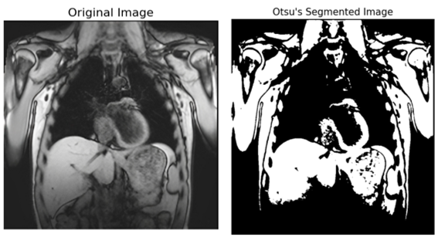
4.2 Region Based Segmentation
CODE
# Apply region-based segmentation (you can modify this part as needed)
ret, segmented_image = cv2.threshold(equalized_gray_image, 150, 255, cv2.THRESH_BINARY)

# Plot the segmented image
plt.subplot(2, 4, 7)
plt.imshow(segmented_image, cmap='gray')
plt.title("Region-Based Segmentation", fontsize=16)
plt.axis('off')

# Show the plots
plt.show()

Result
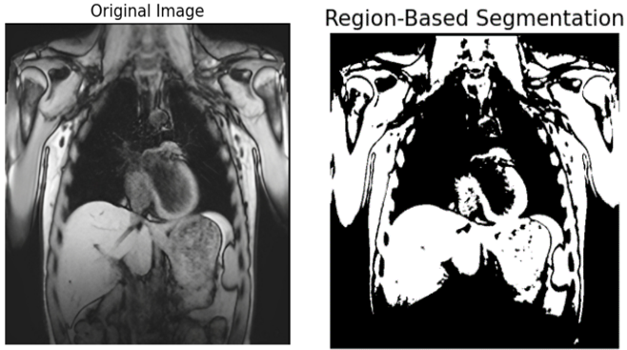

4.3 Edge Based Segmentation
CODE
# Applying Canny edge detection for image segmentation
edges = cv2.Canny(equalized_image, 100, 200) # Adjust the threshold values as needed

# Create a new figure for the segmented edges
plt.figure(figsize=(10, 6))

# Plot the segmented edges
plt.imshow(edges, cmap='gray')
plt.title("Canny Edge Detection", fontsize=16)
plt.axis('off')

Result
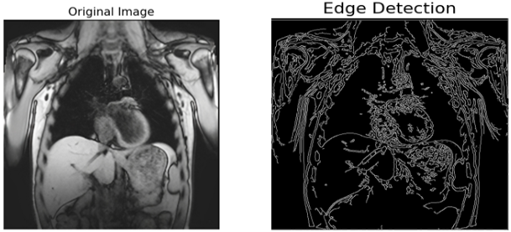

4.4 K-Means Clustering Segmentation
CODE
# Applying Canny edge detection for image segmentation
edges = cv2.Canny(equalized_image, 100, 200) # Adjust the threshold values as needed

# Create a new figure for the segmented edges
plt.figure(figsize=(10, 6))

# Plot the segmented edges using k-means clustering
pixel_values = equalized_image.reshape((-1, 1))
pixel_values = np.float32(pixel_values)

# Define criteria and apply k-means clustering
criteria = (cv2.TERM_CRITERIA_EPS + cv2.TERM_CRITERIA_MAX_ITER, 10, 1.0)
k = 2 # Number of clusters (you can adjust this based on your needs)
_, labels, centers = cv2.kmeans(pixel_values, k, None, criteria, 10, cv2.KMEANS_RANDOM_CENTERS)

# Convert back to 8-bit values
centers = np.uint8(centers)

# Map the labels to the centers
segmented_edges = centers[labels.flatten()]
segmented_edges = segmented_edges.reshape(edges.shape)

# Plot the segmented edges
plt.imshow(segmented_edges, cmap='gray')
plt.title("K-Means Clustering for Edge Segmentation", fontsize=16)
plt.axis('off')

# Show the plots
plt.tight_layout()
plt.show()

Result
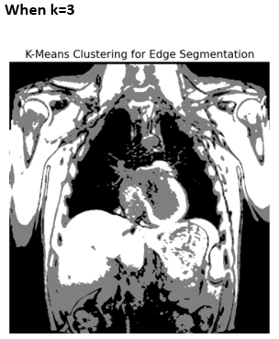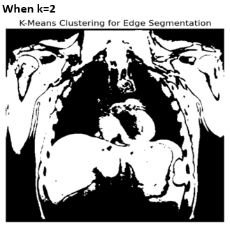

4.5 U-Net Segmentation
CODE
import tensorflow as tf
import zipfile
import numpy as np
import random
import os
from tqdm import tqdm
from skimage.io import imread, imshow
from skimage.transform import resize
import matplotlib.pyplot as plt

import warnings
warnings.filterwarnings('ignore')

SEED = 42
np.random.seed = SEED

UNZIP_PATH = '../input/data-science-bowl-2018/'
TRAIN_PATH = './train/'
TEST_PATH = './test/'

IMG_WIDTH = 128
IMG_HEIGHT = 128
IMG_CHANNELS = 3

# Unzip data
with zipfile.ZipFile(UNZIP_PATH + 'stage1_train.zip', 'r') as zip_ref:
zip_ref.extractall('./train')

with zipfile.ZipFile(UNZIP_PATH + 'stage1_test.zip', 'r') as zip_ref:
zip_ref.extractall('./test')

# get list of all subfolders
train_ids = next(os.walk(TRAIN_PATH))[1]
test_ids = next(os.walk(TEST_PATH))[1]

# define placeholders (also used to replace NaN in images to resize by 0)
X_train = np.zeros((len(train_ids), IMG_HEIGHT, IMG_WIDTH, IMG_CHANNELS), dtype = np.uint8)
Y_train = np.zeros((len(train_ids), IMG_HEIGHT, IMG_WIDTH, 1), dtype = np.bool)
# Loop through all train_ids
for n, id_ in tqdm(enumerate(train_ids), total=len(train_ids)):

# Get the path to the image and mask directories
path = TRAIN_PATH + id_

# Read the image and keep the first IMG_CHANNELS channels
img = imread(path + '/images/' + id_ + '.png')[:, :, :IMG_CHANNELS]

# Resize the image to IMG_HEIGHT x IMG_WIDTH while keeping the pixel values (mode='constant')
img = resize(img, (IMG_HEIGHT, IMG_WIDTH), mode='constant', preserve_range=True)

# Store the processed image into the X_train array at index n
X_train[n] = img

# Initialize an empty mask of dimensions IMG_HEIGHT x IMG_WIDTH x 1 with boolean values
mask = np.zeros((IMG_HEIGHT, IMG_WIDTH, 1), dtype=np.bool)

# Loop through each file in the masks directory
for mask_file in next(os.walk(path + '/masks/'))[2]:

# Read the mask file
mask_ = imread(path + '/masks/' + mask_file)

# Resize the mask to IMG_HEIGHT x IMG_WIDTH while keeping the pixel values (mode='constant'), and add an extra dimension
mask_ = np.expand_dims(resize(mask_, (IMG_HEIGHT, IMG_WIDTH), mode='constant', preserve_range=True), axis=-1)

# Merge all the masks associated with the same image by taking the maximum value at each pixel location
mask = np.maximum(mask, mask_)

# Store the processed mask into the Y_train array at index n
Y_train[n] = mask
# Create an empty array for test images with dimensions as (number of test images, height, width, channels)
# The datatype for the array is uint8 which can hold values from 0 to 255
X_test = np.zeros((len(test_ids), IMG_HEIGHT, IMG_WIDTH, IMG_CHANNELS), dtype=np.uint8)

# Initialize an empty list to store the original sizes of the test images
sizes_test = []

# Loop through all the test_ids
for n, id_ in tqdm(enumerate(test_ids), total=len(test_ids)):

# Get the path to the test image
path = TEST_PATH + id_

# Read the image and keep the first IMG_CHANNELS channels
img = imread(path + '/images/' + id_ + '.png')[:, :, :IMG_CHANNELS]

# Append the original size of the image to sizes_test list
sizes_test.append([img.shape[0], img.shape[1]])

# Resize the image to IMG_HEIGHT x IMG_WIDTH while keeping the pixel values
img = resize(img, (IMG_HEIGHT, IMG_WIDTH), mode='constant', preserve_range=True)

# Store the processed image into the X_test array at index n
X_test[n] = img

# Create a function for a convolution block
def conv_block(inputs, num_filters):
x = tf.keras.layers.Conv2D(num_filters, (3, 3), activation="relu",
kernel_initializer="he_normal", padding="same")(inputs)
x = tf.keras.layers.Dropout(0.1)(x)
x = tf.keras.layers.Conv2D(num_filters, (3, 3), activation="relu",
kernel_initializer="he_normal", padding="same")(x)
return x

# Create a function for the expanding path
def upsample_block(inputs, conv_prev, num_filters):
up = tf.keras.layers.Conv2DTranspose(num_filters, (2, 2), strides=(2, 2), padding="same")(inputs)
concat = tf.keras.layers.concatenate([up, conv_prev])
conv = conv_block(concat, num_filters)
return conv

# Inputs
inputs = tf.keras.layers.Input((IMG_WIDTH, IMG_HEIGHT, IMG_CHANNELS))

# Normalization
s = tf.keras.layers.Lambda(lambda x: x/255.0)(inputs)

# Contraction path
c1 = conv_block(s, 16)
p1 = tf.keras.layers.MaxPooling2D((2, 2))(c1)

c2 = conv_block(p1, 32)
p2 = tf.keras.layers.MaxPooling2D((2, 2))(c2)

c3 = conv_block(p2, 64)
p3 = tf.keras.layers.MaxPooling2D((2, 2))(c3)

c4 = conv_block(p3, 128)
p4 = tf.keras.layers.MaxPooling2D((2, 2))(c4)

c5 = conv_block(p4, 256)

# Expansive path
c6 = upsample_block(c5, c4, 128)
c7 = upsample_block(c6, c3, 64)
c8 = upsample_block(c7, c2, 32)
c9 = upsample_block(c8, c1, 16)

# Output layer
outputs = tf.keras.layers.Conv2D(1, (1, 1), activation='sigmoid')(c9)

# Model
model = tf.keras.Model(inputs=[inputs], outputs=[outputs])

# Compilation
model.compile(optimizer='adam', loss='binary_crossentropy', metrics=['accuracy'])

# Summary
model.summary()

# Callbacks
checkpoint = tf.keras.callbacks.ModelCheckpoint('model.h5', verbose = 1, save_best_only = True)
callbacks = [
tf.keras.callbacks.EarlyStopping(patience = 5, monitor = 'val_loss'),
tf.keras.callbacks.TensorBoard(log_dir = 'logs')
]

results = model.fit(
X_train,
Y_train,
validation_split = 0.1,
batch_size = 16,
epochs = 25,
callbacks = callbacks)

Result
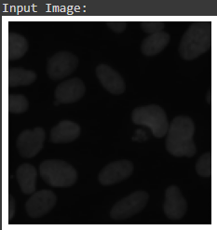
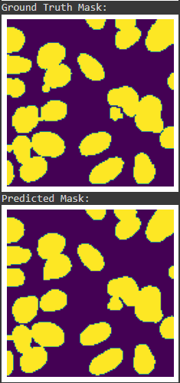

4.6 SegNet Segmentation
CODE
import cv2
import imageio
from PIL import Image
import numpy as np
from keras.preprocessing.image import img_to_array
from keras import backend as K
from keras.layers import Layer
from keras.layers import Input
from keras.layers.convolutional import Convolution2D
from keras.layers.core import Activation, Reshape
from keras.layers.normalization import BatchNormalization
from keras.models import Model
import argparse
import pandas as pd
import tensorflow as tf
import matplotlib.pyplot as plt

class MaxPoolingWithArgmax2D(Layer):

def __init__(
self,
pool_size=(2, 2),
strides=(2, 2),
padding='same',
**kwargs):
super(MaxPoolingWithArgmax2D, self).__init__(**kwargs)
self.padding = padding
self.pool_size = pool_size
self.strides = strides

def call(self, inputs, **kwargs):
padding = self.padding
pool_size = self.pool_size
strides = self.strides
ksize = [1, pool_size[0], pool_size[1], 1]
padding = padding.upper()
strides = [1, strides[0], strides[1], 1]
output, argmax = tf.nn.max_pool_with_argmax(
inputs,
ksize=ksize,
strides=strides,
padding=padding)

argmax = K.cast(argmax, K.floatx())
return [output, argmax]

def compute_output_shape(self, input_shape):
ratio = (1, 2, 2, 1)
output_shape = [
dim // ratio[idx]
if dim is not None else None
for idx, dim in enumerate(input_shape)]
output_shape = tuple(output_shape)
return [output_shape, output_shape]

def compute_mask(self, inputs, mask=None):
return 2 * [None]

class MaxUnpooling2D(Layer):
def __init__(self, size=(2, 2), **kwargs):
super(MaxUnpooling2D, self).__init__(**kwargs)
self.size = size

def call(self, inputs, output_shape=None):
updates, mask = inputs[0], inputs[1]
with tf.compat.v1.variable_scope(self.name):
mask = K.cast(mask, 'int32')
input_shape = tf.shape(updates, out_type='int32')

if output_shape is None:
output_shape = (
input_shape[0],
input_shape[1] * self.size[0],
input_shape[2] * self.size[1],
input_shape[3])

ret = tf.scatter_nd(K.expand_dims(K.flatten(mask)),
K.flatten(updates),
[K.prod(output_shape)])

input_shape = updates.shape
out_shape = [-1,
input_shape[1] * self.size[0],
input_shape[2] * self.size[1],
input_shape[3]]
return K.reshape(ret, out_shape)

def compute_output_shape(self, input_shape):
mask_shape = input_shape[1]
return (
mask_shape[0],
mask_shape[1]*self.size[0],
mask_shape[2]*self.size[1],
mask_shape[3]
)

def segnet(input_shape, n_labels, kernel=3, pool_size=(2, 2), output_mode="softmax"):
# encoder
inputs = Input(shape=input_shape)

conv_1 = Convolution2D(64, (kernel, kernel), padding="same")(inputs)
conv_1 = BatchNormalization()(conv_1)
conv_1 = Activation("relu")(conv_1)
conv_2 = Convolution2D(64, (kernel, kernel), padding="same")(conv_1)
conv_2 = BatchNormalization()(conv_2)
conv_2 = Activation("relu")(conv_2)

pool_1, mask_1 = MaxPoolingWithArgmax2D(pool_size)(conv_2)

conv_3 = Convolution2D(128, (kernel, kernel), padding="same")(pool_1)
conv_3 = BatchNormalization()(conv_3)
conv_3 = Activation("relu")(conv_3)
conv_4 = Convolution2D(128, (kernel, kernel), padding="same")(conv_3)
conv_4 = BatchNormalization()(conv_4)
conv_4 = Activation("relu")(conv_4)

pool_2, mask_2 = MaxPoolingWithArgmax2D(pool_size)(conv_4)

conv_5 = Convolution2D(256, (kernel, kernel), padding="same")(pool_2)
conv_5 = BatchNormalization()(conv_5)
conv_5 = Activation("relu")(conv_5)
conv_6 = Convolution2D(256, (kernel, kernel), padding="same")(conv_5)
conv_6 = BatchNormalization()(conv_6)
conv_6 = Activation("relu")(conv_6)

pool_3, mask_3 = MaxPoolingWithArgmax2D(pool_size)(conv_6)

conv_8 = Convolution2D(512, (kernel, kernel), padding="same")(pool_3)
conv_8 = BatchNormalization()(conv_8)
conv_8 = Activation("relu")(conv_8)

pool_4, mask_4 = MaxPoolingWithArgmax2D(pool_size)(conv_8)

conv_11 = Convolution2D(512, (kernel, kernel), padding="same")(pool_4)
conv_11 = BatchNormalization()(conv_11)
conv_11 = Activation("relu")(conv_11)

pool_5, mask_5 = MaxPoolingWithArgmax2D(pool_size)(conv_11)
print("Build enceder done..")

# decoder

unpool_1 = MaxUnpooling2D(pool_size)([pool_5, mask_5])

conv_14 = Convolution2D(512, (kernel, kernel), padding="same")(unpool_1)
conv_14 = BatchNormalization()(conv_14)
conv_14 = Activation("relu")(conv_14)

unpool_2 = MaxUnpooling2D(pool_size)([conv_14, mask_4])

conv_17 = Convolution2D(512, (kernel, kernel), padding="same")(unpool_2)
conv_17 = BatchNormalization()(conv_17)
conv_17 = Activation("relu")(conv_17)
conv_19 = Convolution2D(256, (kernel, kernel), padding="same")(conv_17)
conv_19 = BatchNormalization()(conv_19)
conv_19 = Activation("relu")(conv_19)

unpool_3 = MaxUnpooling2D(pool_size)([conv_19, mask_3])

conv_20 = Convolution2D(256, (kernel, kernel), padding="same")(unpool_3)
conv_20 = BatchNormalization()(conv_20)
conv_20 = Activation("relu")(conv_20)
conv_21 = Convolution2D(128, (kernel, kernel), padding="same")(conv_20)
conv_21 = BatchNormalization()(conv_21)
conv_21 = Activation("relu")(conv_21)

unpool_4 = MaxUnpooling2D(pool_size)([conv_21, mask_2])

conv_23 = Convolution2D(128, (kernel, kernel), padding="same")(unpool_4)
conv_23 = BatchNormalization()(conv_23)
conv_23 = Activation("relu")(conv_23)
conv_24 = Convolution2D(64, (kernel, kernel), padding="same")(conv_23)
conv_24 = BatchNormalization()(conv_24)
conv_24 = Activation("relu")(conv_24)

unpool_5 = MaxUnpooling2D(pool_size)([conv_24, mask_1])

conv_25 = Convolution2D(64, (kernel, kernel), padding="same")(unpool_5)
conv_25 = BatchNormalization()(conv_25)
conv_25 = Activation("relu")(conv_25)

conv_26 = Convolution2D(n_labels, (1, 1), padding="valid")(conv_25)
conv_26 = BatchNormalization()(conv_26)
conv_26 = Reshape(
(input_shape[0] * input_shape[1], n_labels),
input_shape=(input_shape[0], input_shape[1], n_labels),
)(conv_26)

outputs = Activation(output_mode)(conv_26)
print("Build decoder done..")

model = Model(inputs=inputs, outputs=outputs, name="SegNet")

return model

model = segnet((224,224,3), n_labels=5 ,kernel=3, pool_size=(2,2), output_mode="softmax")

print(model.summary())

print("tf.__version__ is", tf.__version__)
print("tf.keras.__version__ is:", tf.keras.__version__)

def exr_to_jpg(path):
im = imageio.imread(path)
im_gamma_correct = np.clip(np.power(im, 0.45), 0, 1)
im_fixed = Image.fromarray(np.uint8(im_gamma_correct*255))
return im_fixed

def category_label(labels, dims, n_labels):
x = np.zeros([dims[0], dims[1], n_labels])
for i in range(dims[0]):
for j in range(dims[1]):
f=int(labels[i,j])
x[i, j, f] = 1
x = x.reshape(dims[0] * dims[1], n_labels)
return x
def colorize(img):
w=img.shape[0]
h=img.shape[1]
z=img.shape[2]
l=np.zeros((w,h,3))
for i in range(w):
for j in range(h):
if img[i,j,0]==1:
l[i,j,0]=0
l[i,j,1]=0
l[i,j,2]=0
elif img[i,j,1]==1:
l[i,j,0]=255
l[i,j,1]=0
l[i,j,2]=0
elif img[i,j,2]==1:
l[i,j,0]=0
l[i,j,1]=255
l[i,j,2]=0
elif img[i,j,3]==1:
l[i,j,0]=0
l[i,j,1]=0
l[i,j,2]=255
elif img[i,j,4]==1:
l[i,j,0]=238
l[i,j,1]=197
l[i,j,2]=145
return l

def class_pixels(img):
w=img.shape[0]
h=img.shape[1]
z=img.shape[2]
l=np.zeros((w,h,z))
for i in range(w):
for j in range(h):
for f in range(z-1):
if img[i,j,f]==np.max([img[i,j,0],img[i,j,1],img[i,j,2],img[i,j,3],img[i,j,4]]):
l[i,j,f]=1
return l

def data_gen_small(img_dir,mask_dir,depth_dir,liste, batch_size, dims=(224,224), n_labels=5):
while True:
ix = np.random.choice(liste, batch_size)
imgs = []
labels = []
for index in ix:
# images
img_path = img_dir[index]
original_img = exr_to_jpg(img_path)
array_img = img_to_array(original_img)/255
imgs.append(array_img)

# masks
mask_path = mask_dir[index]
original_mask=cv2.imread(mask_path,cv2.IMREAD_ANYCOLOR | cv2.IMREAD_ANYDEPTH)
array_mask = category_label(original_mask[:, :, 0], dims, n_labels)
labels.append(array_mask)

imgs = np.array(imgs)
labels = np.array(labels)
yield imgs, labels

import os
rgb=[]
depth=[]
mask=[]
node=[]

for dirs,subdir,files in os.walk('../input/synthetic-rgbd-images-of-plants/dataset of synthetic rgb-d plants/rgb_map'):
for file_name in files:
if file_name.endswith(".exr"):
path_file=dirs+os.sep+file_name
depth_file='../input/synthetic-rgbd-images-of-plants/dataset of synthetic rgb-d plants/depth_map/profondeur_map/'+file_name
mask_file='../input/synthetic-rgbd-images-of-plants/dataset of synthetic rgb-d plants/semantic_map/segmentation2_map/'+file_name
node_file='../input/synthetic-rgbd-images-of-plants/dataset of synthetic rgb-d plants/nodes_map/internoeuds_map/'+file_name
rgb.append(path_file)
depth.append(depth_file)
mask.append(mask_file)
node.append(node_file)

liste=np.arange(1,10000)
np.random.shuffle(liste)

train_list=liste[0:8000]
val_list=liste[8000:9000]
test_list=liste[9000:9999]

train_gen = data_gen_small(rgb
,mask,depth,liste=train_list,batch_size=16,dims=(224,224),n_labels=5)
val_gen=data_gen_small(rgb
,mask,depth,liste=val_list,batch_size=16,dims=(224,224),n_labels=5)
test_gen = data_gen_small(rgb
,mask,depth,liste=test_list,batch_size=1,dims=(224,224),n_labels=5)

history=model.fit_generator(
train_gen,
steps_per_epoch=500,
epochs=50,
validation_data=val_gen,
validation_steps=62
)

h=0
for i in test_list:
if h<50:

img_path = rgb[i]
original_img = exr_to_jpg(img_path)

plt.figure(figsize=(15,15))
plt.subplot(1,2,1)
plt.imshow(original_img)
array_img=img_to_array(original_img)/255

array_img2 = np.reshape(array_img, (1,224,224,3))
y_pred=model.predict(array_img2)
y_pred=np.reshape(y_pred,(224,224,6))
c=class_pixels(y_pred)
o=colorize(c)
plt.subplot(1,2,2)
plt.imshow(o)
plt.show()
h+=1
else:
break

Result
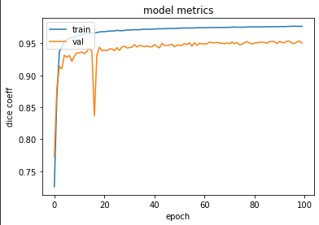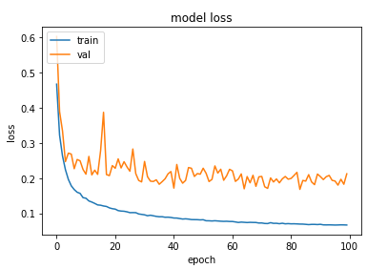
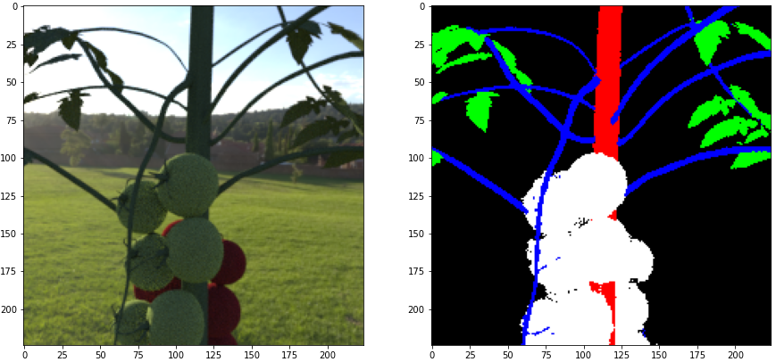
6. Proposed Application Result

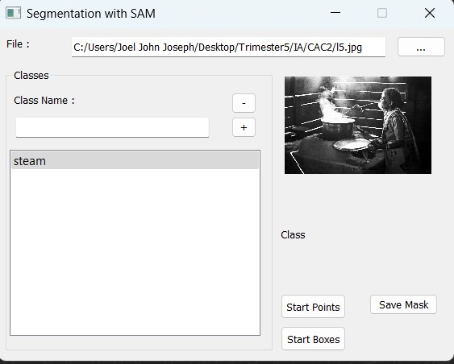
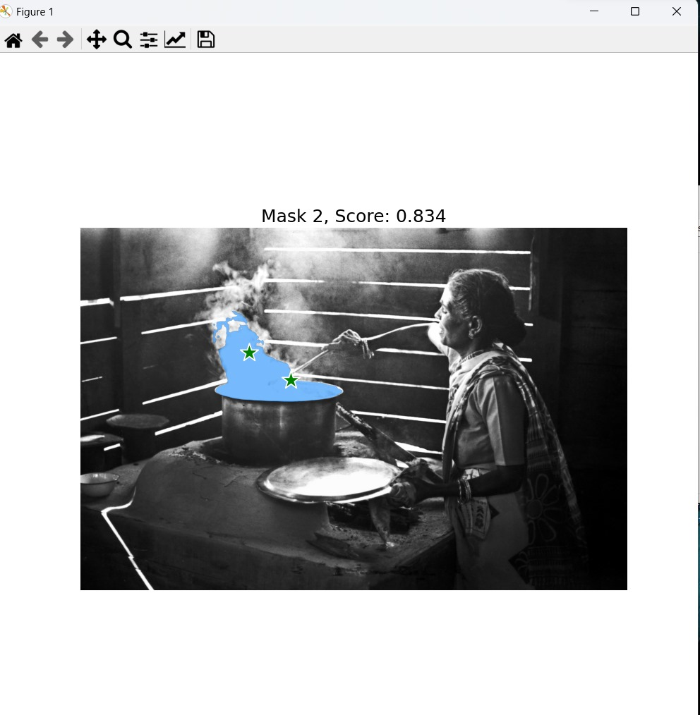
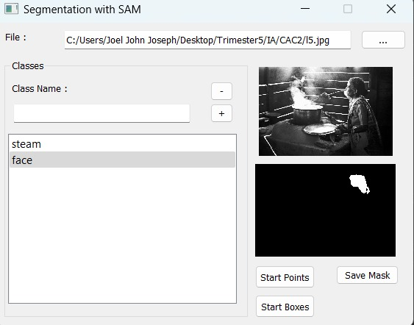
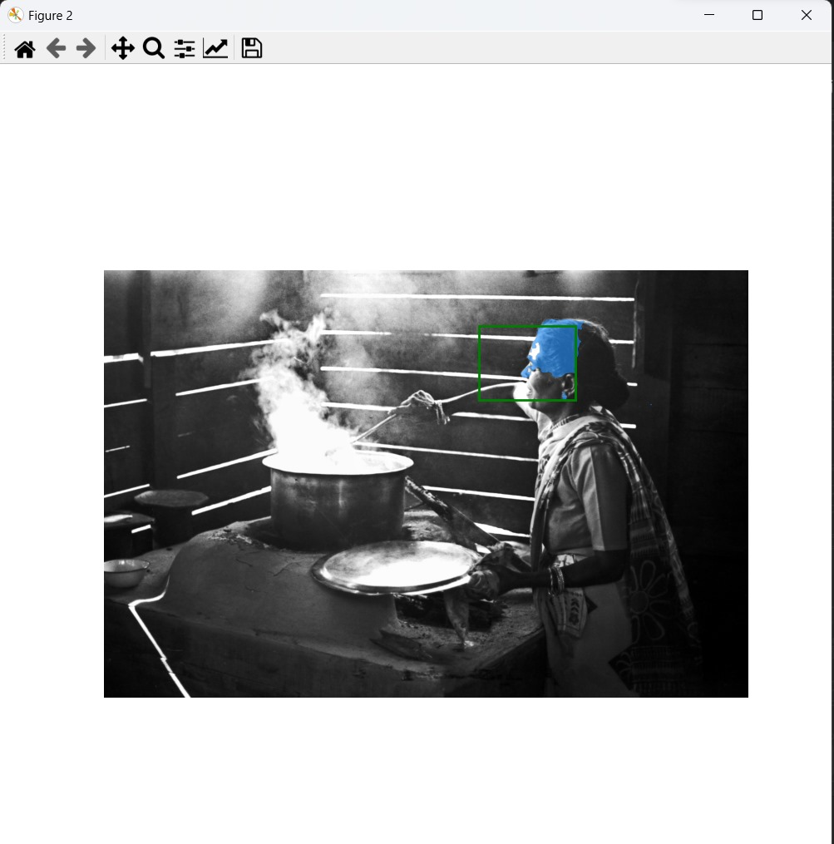
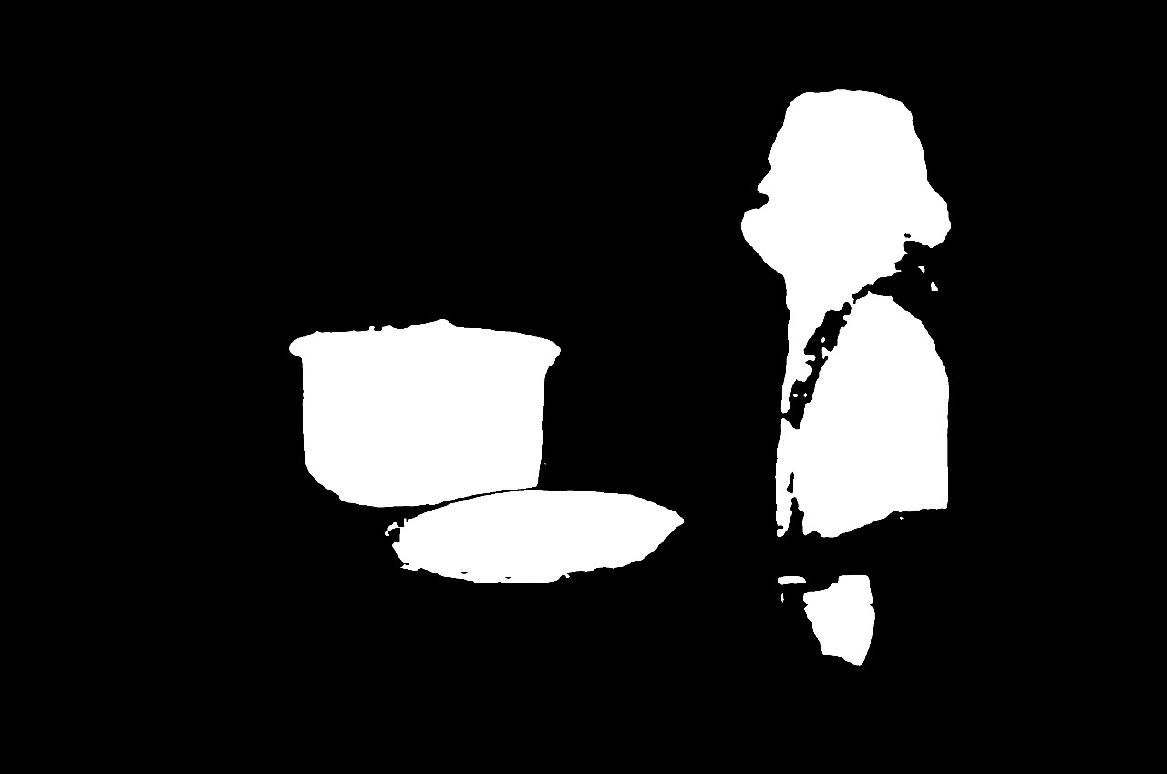
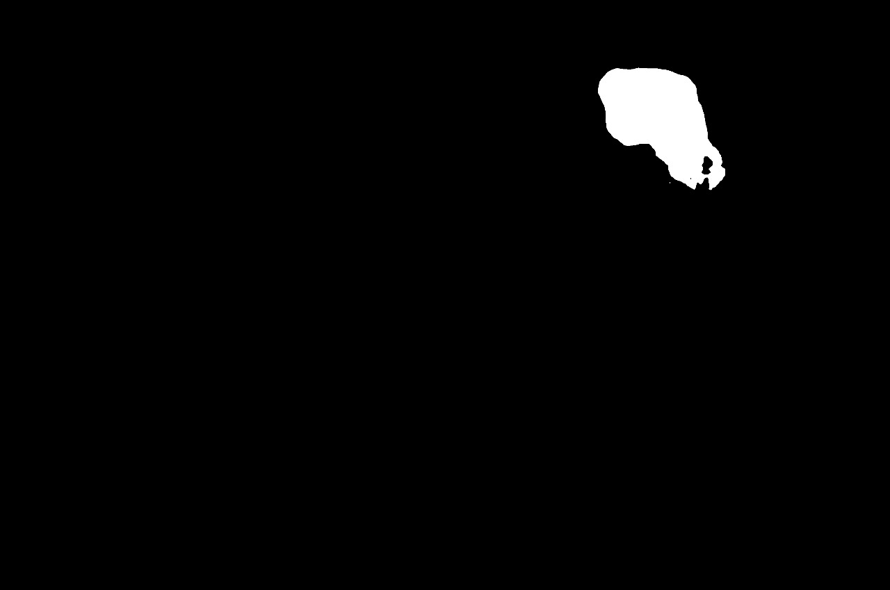
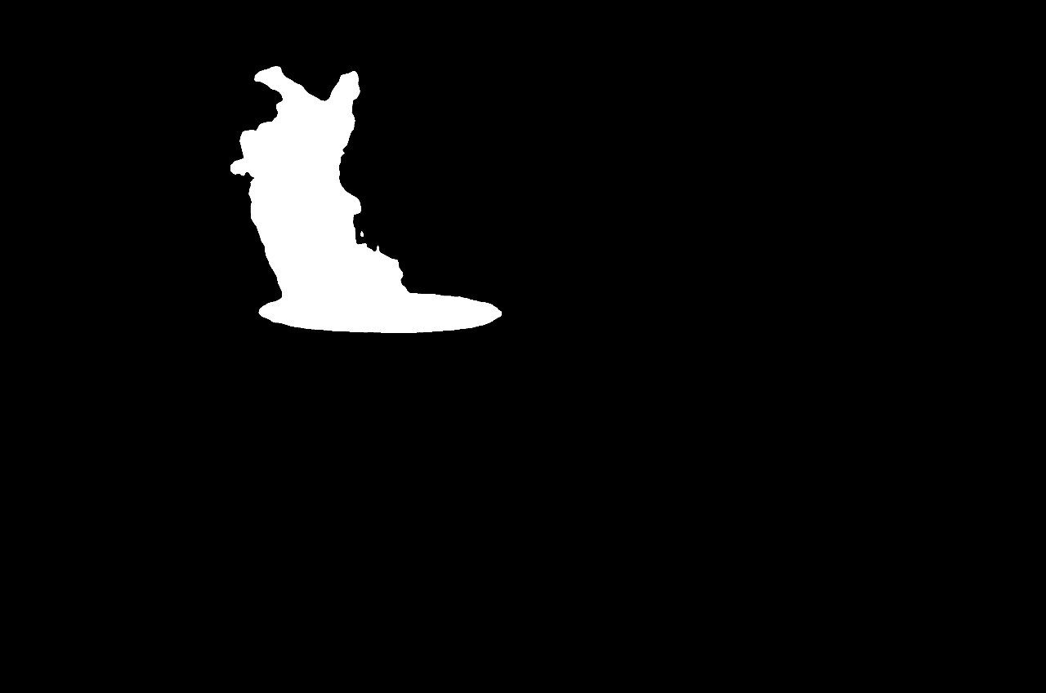
7. Plan of Work

Name | Task
Joel John Joseph | Deep Net Segmentation and CNN Segmentation.  Application Backend
Rajarshi Barman | SegNet Segmentation and Contour Segmentation  Application Backend
Anna Danties | Region Based Segmentation and Otsu Segmentation  Application Integration
Dinesh R | U-Net Segmentation and K Means Clustering Segmentation  Application Integration
Divesh Bhandari | Edge Based Segmentation and Region Based Segmentation  Application Frontend
Subham Raithatha | Canny Edge Based Segmentation and  Thresholding  Application Frontend

